**MMO system-QL tool user manual**

February 2018 ver.

BepiColombo MMO system team

1. How to install

【1.1】Install VMware Workstation player

<https://my.vmware.com/web/vmware/downloads>

# Free versions are available only for Windows and Linux.

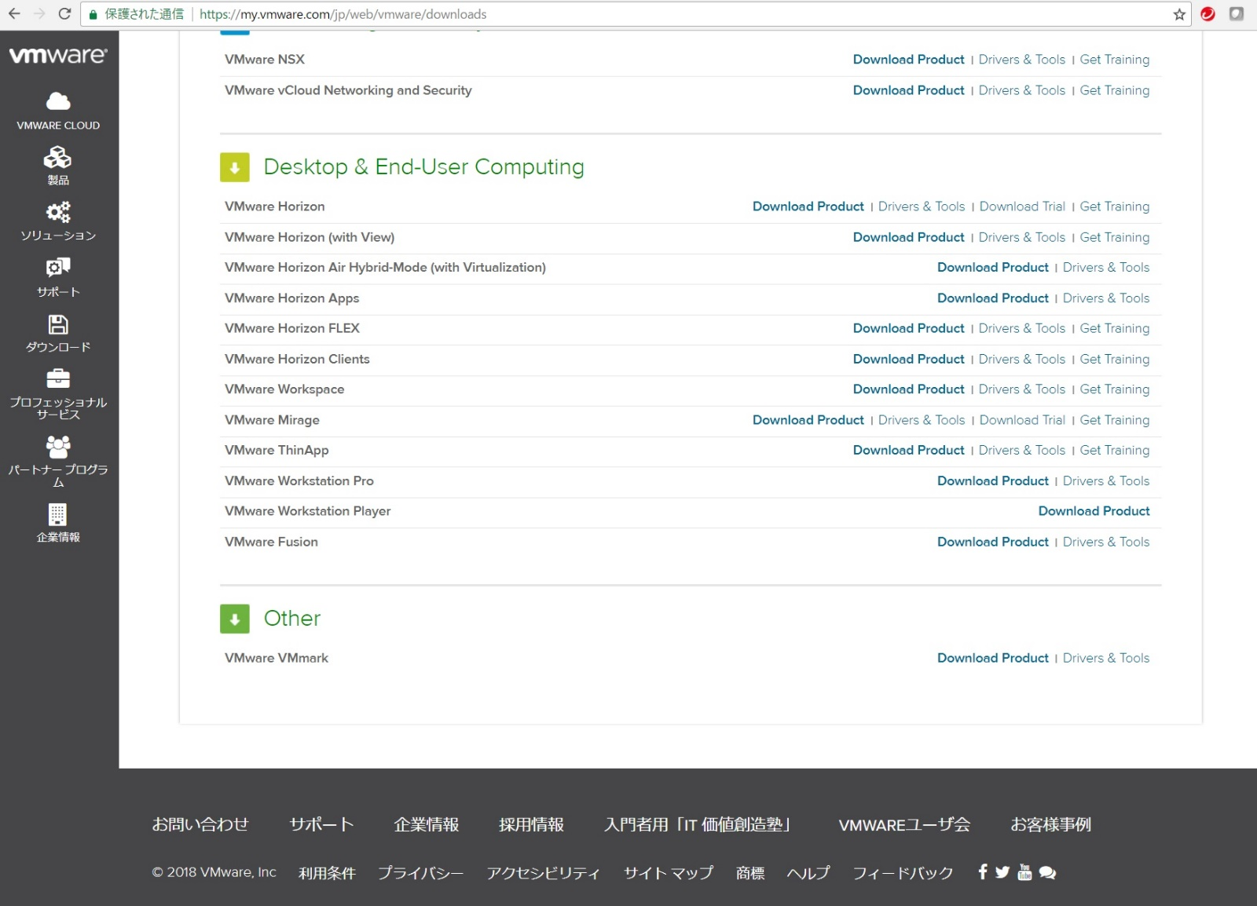

【1.2】Extract the distributed file ”mmo_tlmmonVM_ver20180208.zip” at anywhere in your PC

【1.3】Connect your PC to your network

【2. Boot the virtual Cent OS on VMware】

1. Start VMware Workstation Player

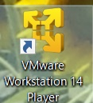

2. Play virtual machine

<Only for the first time>

Select “Open a Virtual Machine” -> the directory you decompressed the tool (zip file) in Step 1.2 -> mmo_tlmmonVM_ver20180208/mmo_erg/CentOS 5.8.vmx

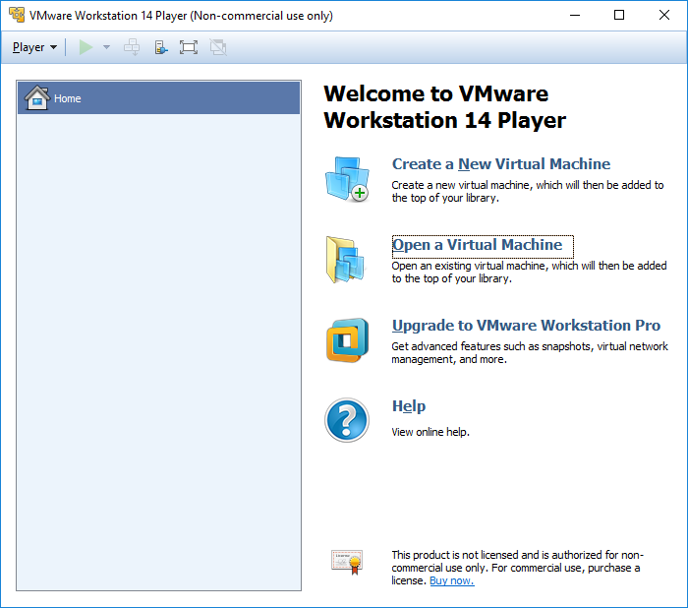

<Normal step>

Play virtual machine

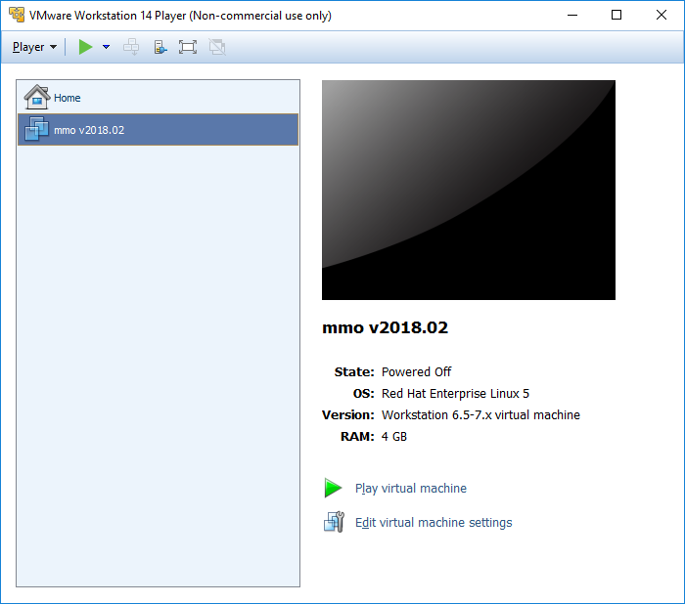

3. Log in CentOS

　User name:　mmo_user

　PW:　mmo_user

# Default keyboard setting: US keyboard

4. Start system-QL tool

* 1. Applications -> TLM Monitor -> Quick Look（QL）

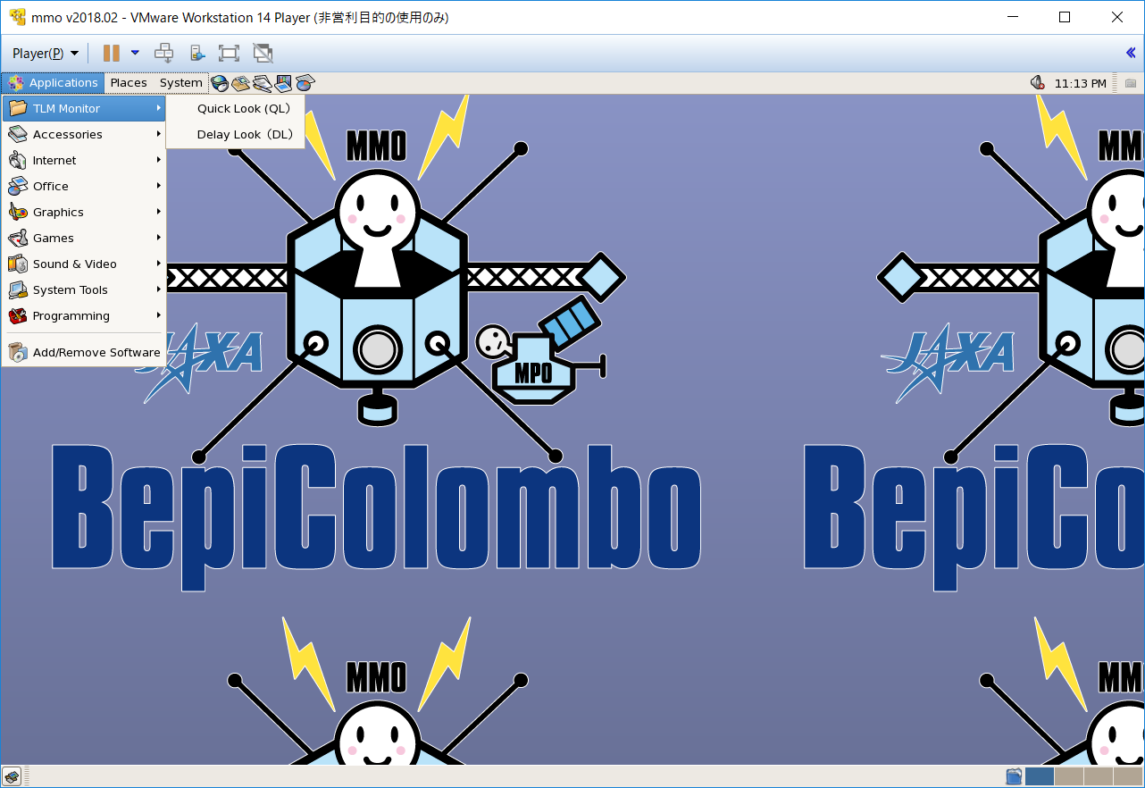

* 1. Connection Status Window -> Connect -> Data Source Select

Select Antenna ID -> Connect

10_MMO_X_RL　：　Nominal (e.g., Estec Test MMO TLM recieve)

11_MMO_X_RL_1553B　：　1553B connection <NECP C/O test, Venus-flyby test>

(Estec Test MMO-1553B TLM recieve)

20_MMO_X_RL_EDDS-A　：　Data via ESOC/EDDS-GW A

( MMO TLM Receive From ESOC EDDS-A)

21_MMO_X_RL_EDDS-B　：　Data via ESOC/EDDS-GW B

( MMO TLM Receive From ESOC EDDS-B)

30_MMO_X_RL_CEB　：　Data via ESOC/EDDS-GW　Cebreros

( MMO TLM Receive From ESOC Cebreros)

31_MMO_X_RL_MAL　：　Data via ESOC/EDDS-GW　Malargue

( MMO TLM Receive From ESOC Malargue)

32_MMO_X_RL_NOR　：　Data via ESOC/EDDS-GW　NewNorcia

( MMO TLM Receive From ESOC NewNorcia)

33_MMO_X_RL_ERS　：　Data via ESOC/EDDS-GW　ReferenceSta

( MMO TLM Receive From ESOC ReferenceStation)

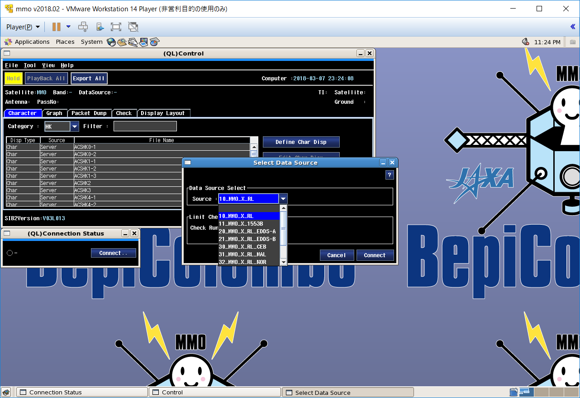

* 1. Open QL window:

Character -> Category: HK -> Select each instrument file

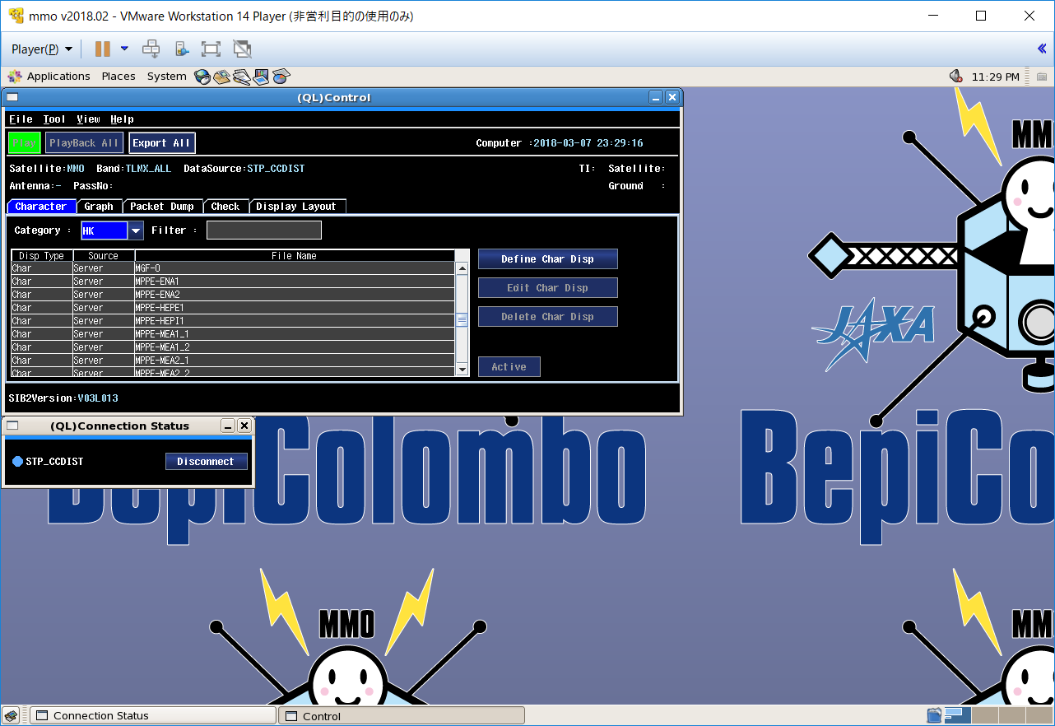

5. Start system-DL tool

1. Applications -> TLM Monitor -> Delay Look（DL）
2. Control Window -> Select Data -> Data Source Select

Select Antenna ID -> Receive

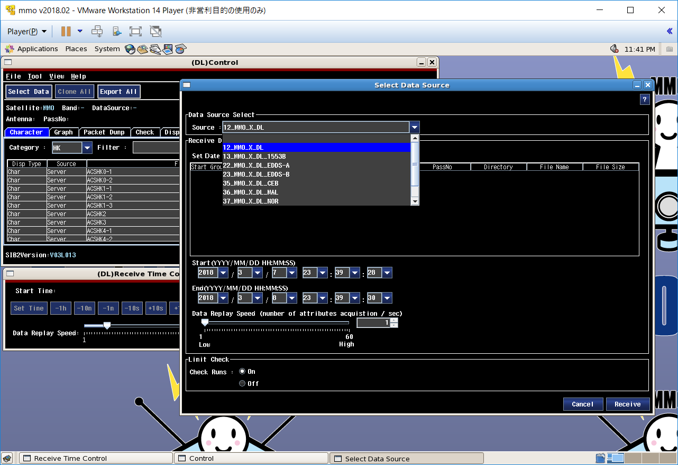

12_MMO_X_DL　：　Nominal (e.g., Estec Test MMO TLM recieve)

13_MMO_X_DL_1553B　：　1553B connection <NECP C/O test, Venus-flyby test>

(Estec Test MMO-1553B TLM recieve)

22_MMO_X_DL_EDDS-A　：　Data via ESOC/EDDS-GW A

( MMO TLM Receive From ESOC EDDS-A)

23_MMO_X_DL_EDDS-B　：　Data via ESOC/EDDS-GW B

( MMO TLM Receive From ESOC EDDS-B)

35_MMO_X_DL_CEB　：　Data via ESOC/EDDS-GW　Cebreros

( MMO TLM Receive From ESOC Cebreros)

36_MMO_X_DL_MAL　：　Data via ESOC/EDDS-GW　Malargue

( MMO TLM Receive From ESOC Malargue)

37_MMO_X_DL_NOR　：　Data via ESOC/EDDS-GW　NewNorcia

( MMO TLM Receive From ESOC NewNorcia)

38_MMO_X_DL_ERS　：　Data via ESOC/EDDS-GW　ReferenceSta

( MMO TLM Receive From ESOC ReferenceStation)

1. Time set

Set Start Time & End Time -> Receive

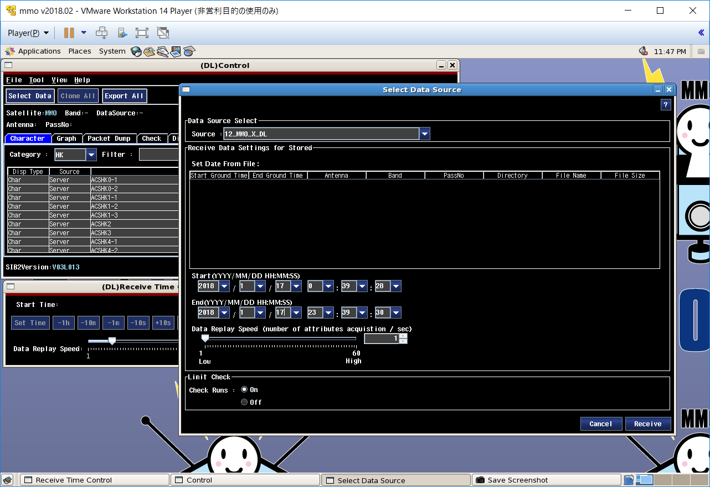

1. Start DL

Push Hold button to start DL

